Week 1

Roll No: 241401046
Name: LINGESH SAI M
Week-01-01

Q1) Objective
This is a simple challenge to help you practice printing to stdout.

We're starting out by printing the most famous computing phrase of all time! In the editor below, use either printf or cout to print the string Hello, World! to stdout.

Input Format

You do not need to read any input in this challenge.

Output Format

Print Hello, World! to stdout.

Sample Output

Hello, World!
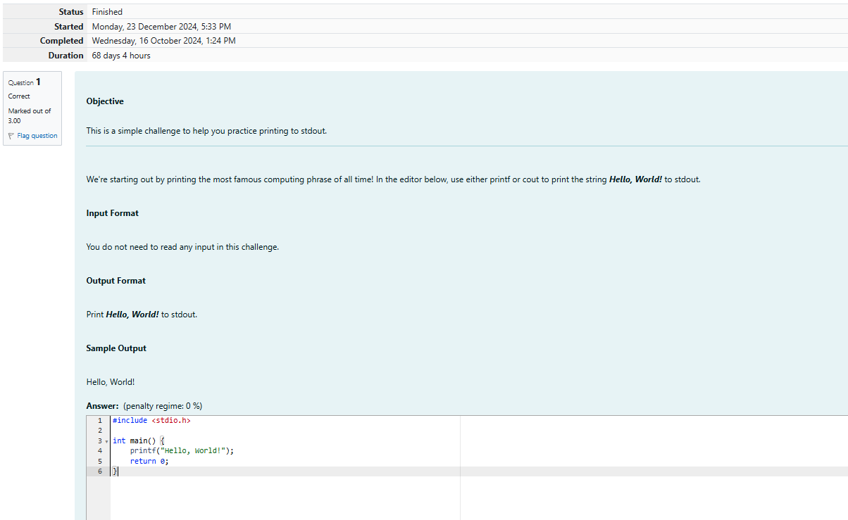
Output:
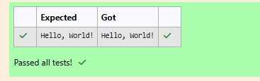

Q2) Objective

This challenge will help you to learn how to take a character, a string and a sentence as input in C.

To take a single character ch as input, you can use scanf("%c", &ch); and printf("%c", ch) writes a character specified by the argument char to stdout:

char ch;
scanf("%c", &ch);
printf("%c", ch);

This piece of code prints the character ch.

Task

You have to print the character, ch.

Input Format

Take a character, ch as input.

Output Format

Print the character, ch.
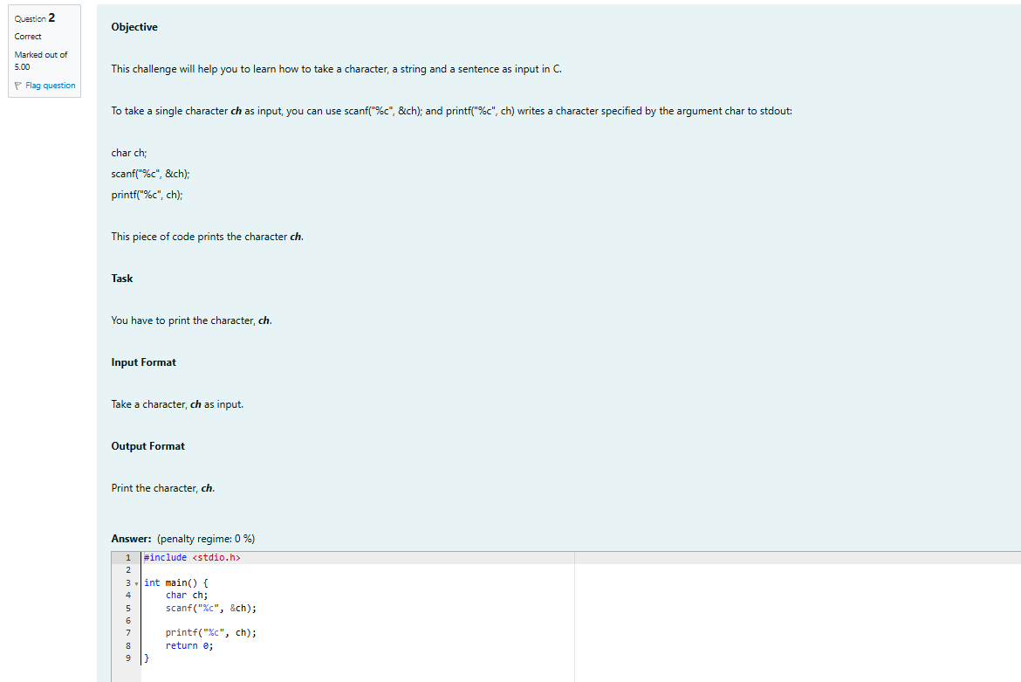
Output:
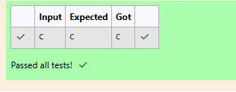

Q3) Objective

The fundamental data types in c are int, float and char. Today, we're discussing int and float data types.

The printf() function prints the given statement to the console. The syntax is printf("format string",argument_list);. In the function, if we are using an integer, character, string or float as argument, then in the format string we have to write %d (integer), %c (character), %s (string), %f (float) respectively.

The scanf() function reads the input data from the console. The syntax is scanf("format string",argument_list);. For ex: The scanf("%d",&number) statement reads integer number from the console and stores the given value in variable number.

To input two integers separated by a space on a single line, the command is scanf("%d %d", &n, &m), where n and m are the two integers.

Task

Your task is to take two numbers of int data type, two numbers of float data type as input and output their sum:

1. Declare 4 variables: two of type int and two of type float.
2. Read 2 lines of input from stdin (according to the sequence given in the 'Input Format' section below) and initialize your 4 variables.
3. Use the + and - operator to perform the following operations:
o Print the sum and difference of two int variable on a new line.
o Print the sum and difference of two float variable rounded to one decimal place on a new line.

Input Format

The first line contains two integers.
The second line contains two floating point numbers.

Constraints

· 1 ≤ integer variables ≤ 104
· 1 ≤ float variables ≤ 104

Output Format

Print the sum and difference of both integers separated by a space on the first line, and the sum and difference of both float (scaled to 1 decimal place) separated by a space on the second line.

Sample Input

10 4
4.0 2.0

Sample Output

14 6
6.0 2.0

Explanation

When we sum the integers 10 and 4, we get the integer 14. When we subtract the second number 4 from the first number 10, we get 6 as their difference.
When we sum the floating-point numbers 4.0 and 2.0, we get 6.0. When we subtract the second number 2.0 from the first number 4.0, we get 2.0 as their difference.
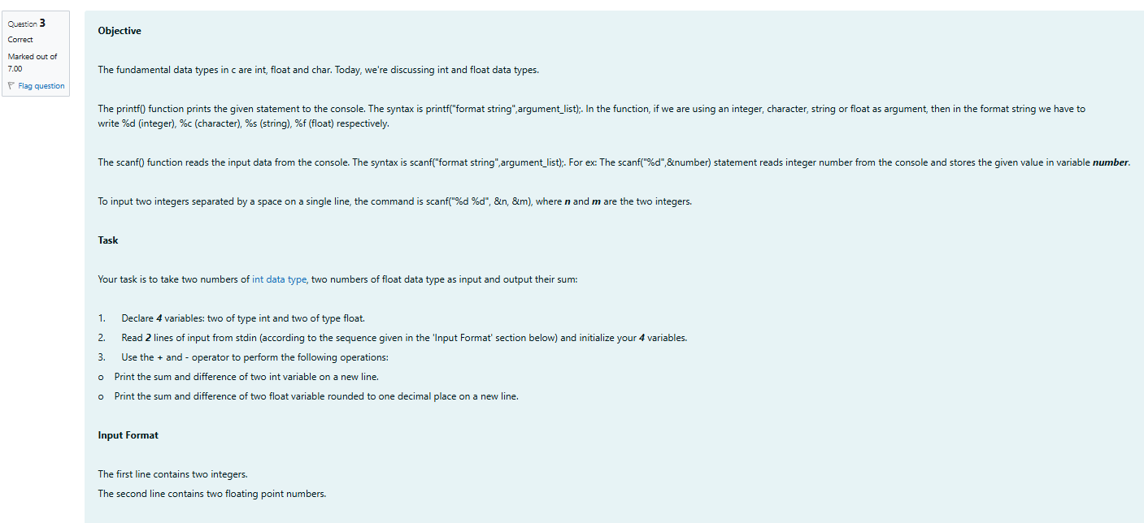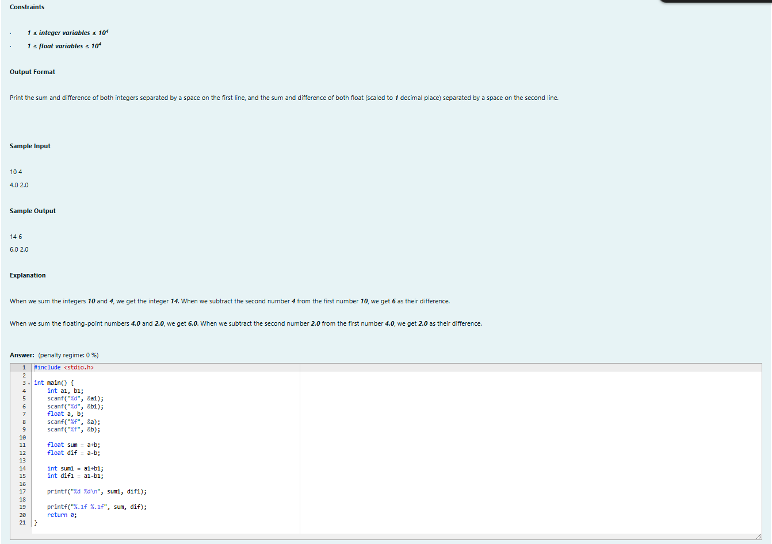
Output:
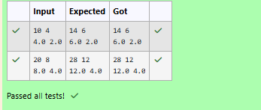

Week-01-02-Practice Session-Coding

Q1) Write a program to input a name (as a single character) and marks of three tests as m1, m2, and m3 of a student considering all the three marks have been given in integer format.

Now, you need to calculate the average of the given marks and print it along with the name as mentioned in the output format section.

All the test marks are in integers and hence calculate the average in integer as well. That is, you need to print the integer part of the average only and neglect the decimal part.

Input format :

Line 1 : Name(Single character)
Line 2 : Marks scored in the 3 tests separated by single space.

Output format :

First line of output prints the name of the student.
Second line of the output prints the average mark.

Constraints

Marks for each student lie in the range 0 to 100 (both inclusive)

Sample Input 1 :

A
3 4 6

Sample Output 1 :

A
4

Sample Input 2 :

T
7 3 8

Sample Output 2 :

T
6

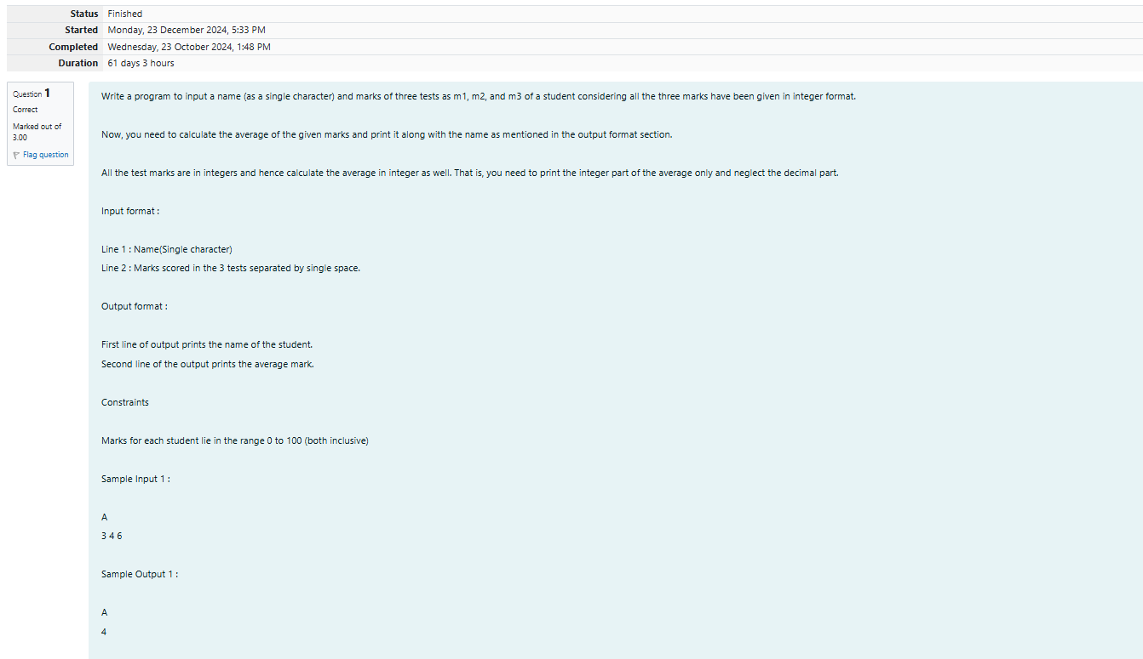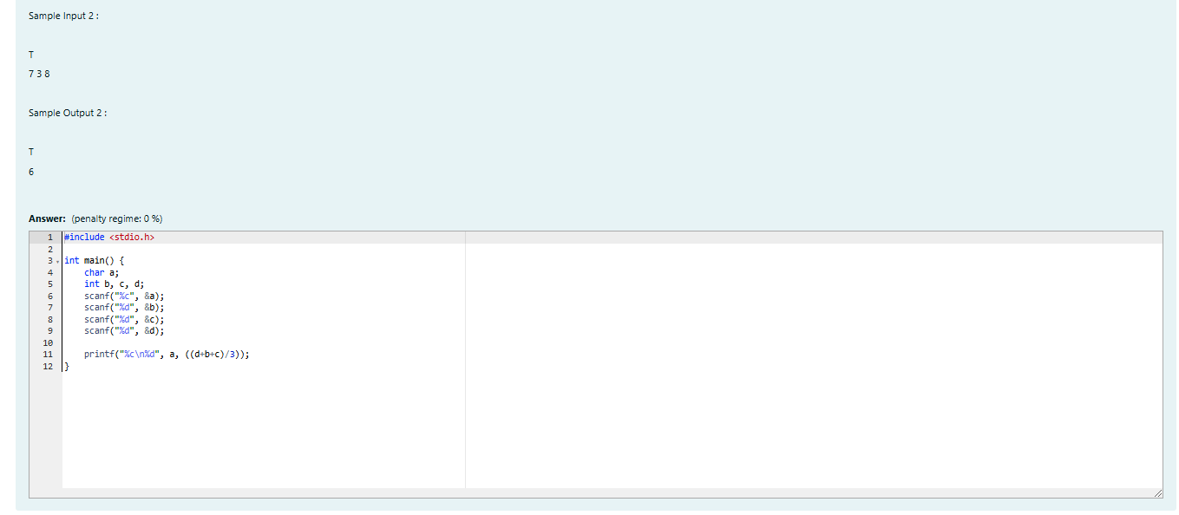
Output:
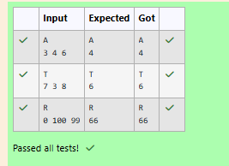

Q2) Some C data types, their format specifiers, and their most common bit widths are as follows:
· Int ("%d"): 32 Bit integer
· Long ("%ld"): 64 bit integer
· Char ("%c"): Character type
· Float ("%f"): 32 bit real value
· Double ("%lf"): 64 bit real value

Reading
To read a data type, use the following syntax:
scanf("`format_specifier`", &val)
For example, to read a character followed by a double:
char ch;
double d;
scanf("%c %lf", &ch, &d);
For the moment, we can ignore the spacing between format specifiers.

Printing
To print a data type, use the following syntax:
printf("`format_specifier`", val)
For example, to print a character followed by a double:
char ch = 'd';
double d = 234.432;
printf("%c %lf", ch, d);
Note: You can also use cin and cout instead of scanf and printf; however, if you are taking a million numbers as input and printing a million lines, it is faster to use scanf and printf.
Input Format
Input consists of the following space-separated values: int, long, char, float, and double, respectively.
Output Format
Print each element on a new line in the same order it was received as input. Note that the floating point value should be correct up to 3 decimal places and the double to 9 decimal places.
Sample Input
3 12345678912345 a 334.23 14049.30493
Sample Output
3
12345678912345
a
334.230
14049.304930000
Explanation
Print int 3,
followed by long 12345678912345,
followed by char a,
followed by float 334.23,
followed by double 14049.30493.
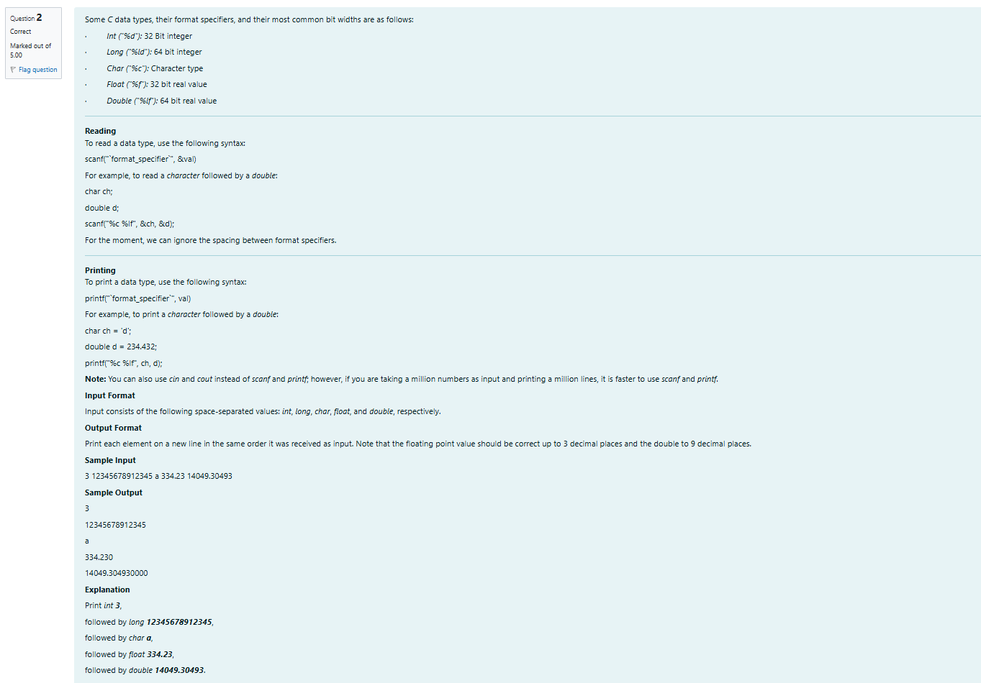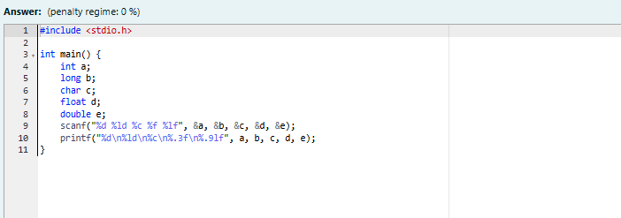

Output:
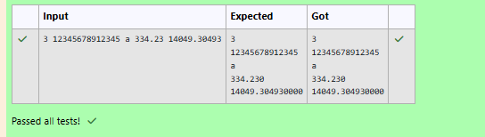

Q3) Write a program to print the ASCII value and the two adjacent characters of the given character.

Input

E

Output

69
D F
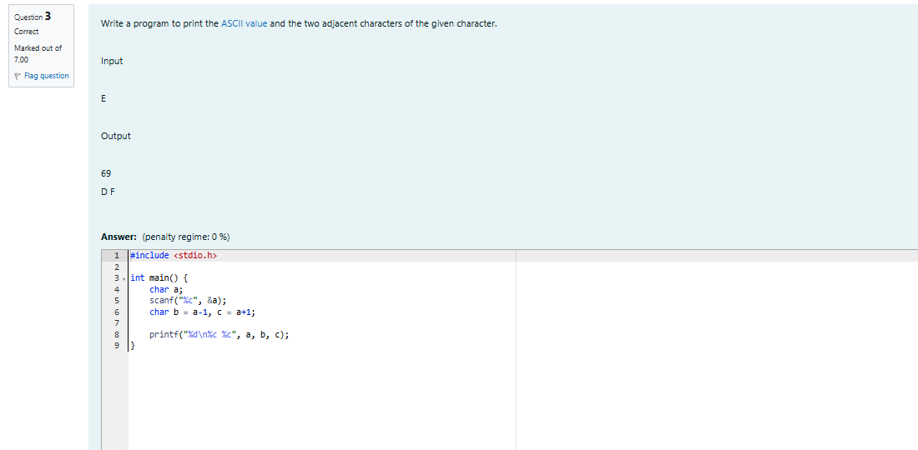

Output:
